What is perceptron

How to Build it ?

How we train it ?

Problems with Perceptron that is solved by Multi Layer Perceptron.

***Perceptron***

Perceptron you can also call it as mathematical model or mathematical function.

The Perceptron is a type of artificial neuron or a simple linear binary classifier. It takes input values, applies weights, and produces an output.

Perceptron is considered as a single-layer neural network that consists of four main parameters named input values (Input nodes), weights and Bias, net sum, and an activation function. The perceptron model begins with the multiplication of all input values and their weights, then adds these values together to create the weighted sum. Then this weighted sum is applied to the activation function 'f' to obtain the desired output. This activation function is also known as the **step function** and is represented by **'f'**.

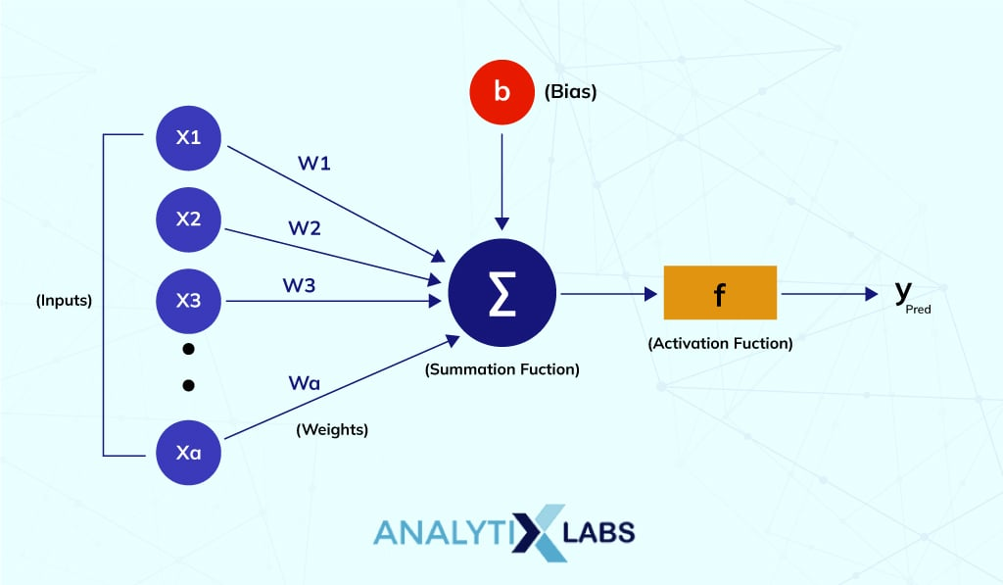

This step function or Activation function plays a vital role in ensuring that output is mapped between required values (0,1) or (-1,1). It is important to note that the weight of input is indicative of the strength of a node. Similarly, an input's bias value gives the ability to shift the activation function curve up or down.

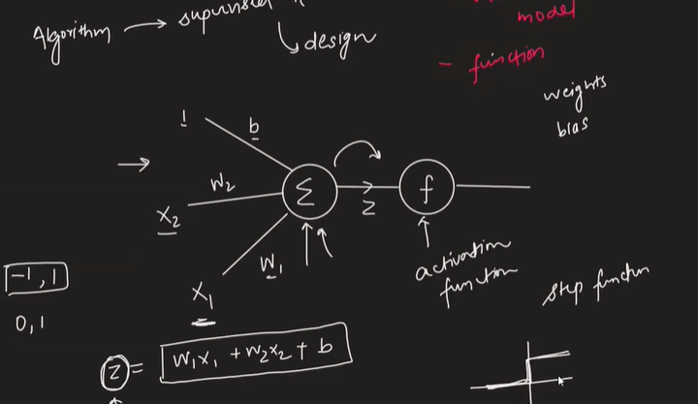

**Activation Function** ka kaam hota hai

Jo Humara Summation Function ka output hai

Usko ek Proper Range mai leekr aana (-1,1)

***Types of Activation Function***

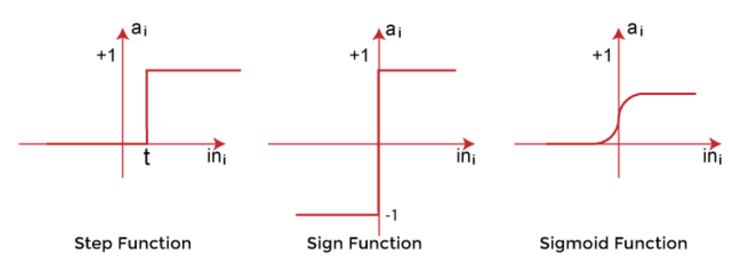

***Step Function:***

*The step function (or Heaviside step function) is a common activation function for a Perceptron. It works by assigning an output of 0 or 1 based on whether the weighted sum of inputs is above or below a certain threshold.*

*Sign Function:*

*The sign function is similar to the step function. It produces an output of -1 or 1 based on whether the weighted sum of inputs is negative or positive.*

*Sigmoid Function:*

*The sigmoid function is another type of activation function that is often used in neural networks, including the perceptron. It squashes the output between 0 and 1, providing a smooth transition between the two states.*

*There are Some More Activation Functions which are used a lot that we will study further.*

*E.g*

*1.) ReLu*

*2.Softmax*

*3.LeakyRelu*

*4. Parametric Relu*

*5.GatedRelu*

*6.Swish*

***W & B ka Value nikalte hai Train karke***

***Example Problem***

Data of 1 Thousand Student with features like IQ, CGPA, & Placement Yes or No

We are Solving this Problem

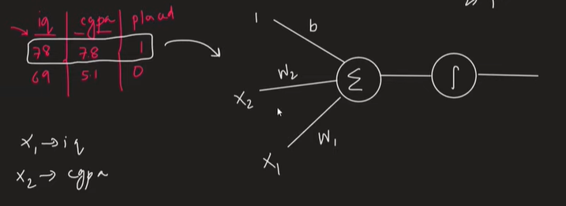

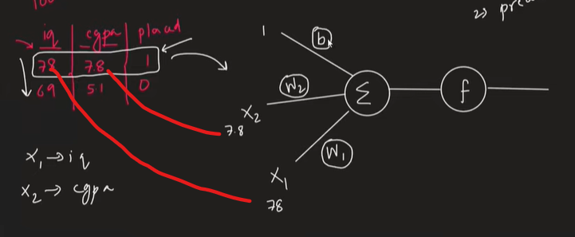

Eg:

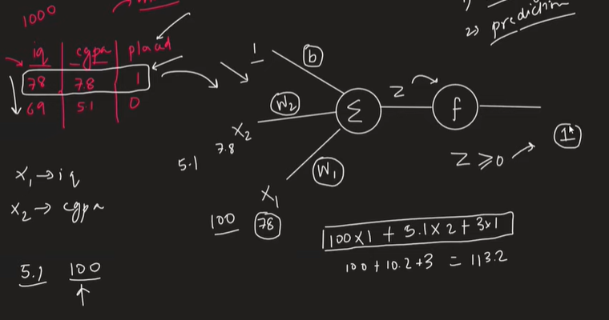

Perceptron mai Weights & Bias ka Value pata hona chaye. We will know this at time of training

***Perceptron vs Neuron***

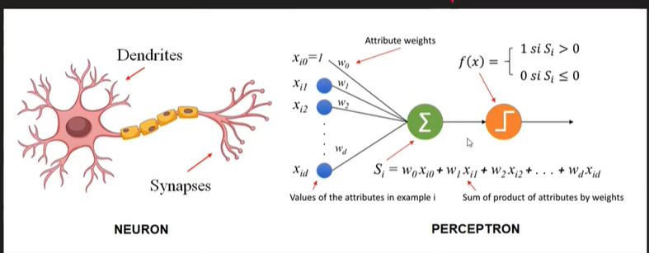

Bhaut saare Neurons apas mai connect hoke Nervous System banate hai

Similarly bhaut saare Perceptron millkr Neural Network banate hai.

Nucleus ke andar kya kch chemical electro reaction chalrhe vo kisko kuch nahi pata duniya mai

Humare perceptron mai pr Simple Mathematical function hai jo Plot karke dekh sakte hai

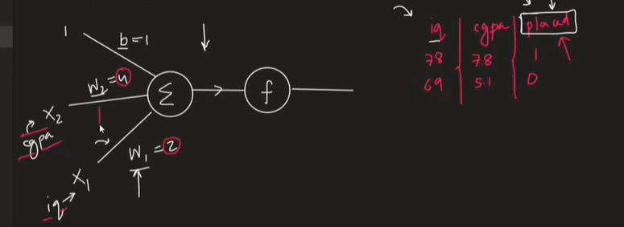

Weights Tell us Inputs ka connection kitna Strong hai.

E.g

Placement hoga ki nahi iska dependence CGPA pr zyaada hai,

As CGPA ka weight 4 hai & IQ ka Weight 2 hai

CGPA ko weight zyaada hai so uska importance zyaada hai.

**Weights tell us Feature Importance.**

**Bias we will discuss further on.**

*Geometric Intuition*

*Perceptron is Nothing but just a Line in Geometric Intuition*

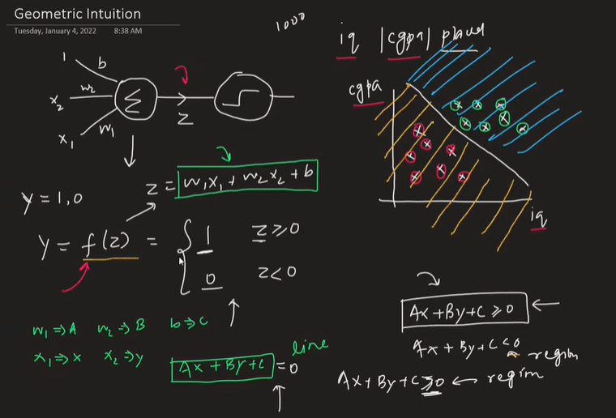

*Perceptron is nothing but a Line*

*Which Creates a Region, It Divides Classes In Different Region*

*That’s why we call Perceptron as Binary Classifier.*

*Isliye we call it as Binary Classifier.*

Suppose inputs aur badhgaye tou fir then Line ke jageh Plane hokr kaam karega

3d mai plane , 4d mai Hyperplane bnnjayega & so on.

***Limitation:***

*Perceptron will only be able to classify Sort of Linear Data.*

*If there is a data that is completely Non-Linear Over their Perceptron will get Failed.*

